Agenda
From Julie Halliday:
For this month’s call, I’d like to discuss the information that will be provided to the National Building Museum for their exhibit. I need to provide them with information/contacts soon. I am seeking volunteers to provide case studies. Feel free to provide other suggestions:
Pipelines affected by natural hazards –
- A case study of a pipeline that was designed to mitigate against a natural hazard (pictures of project needed). In keeping with the theme of examining hazards geographically, a case study of a pipeline project in CA re hurricane design, a case study of a pipeline project in Mississippi re flooding, or a case study of hurricane design for a pipeline project near the Gulf would be appropriate. Design for multiple natural hazards is appropriate as well. Pipeline replacements due to the impacts of a natural hazard is also a good example.
- General information on the potential impacts of natural hazards on pipelines and what is done to mitigate the impacts.
Pipelines as a manmade hazard
- Best practice example of land planning near transmission pipelines.
  - Perhaps the consultation zone ordinance – Billings, SD has an example of a project that was improved through consultation. Please feel free to submit others.
  - Alternatively, an example of a pipeline ROW used as a walking trail or golf course from the PIPA report. Again, if you have case studies you would like to provide, they are welcome.
- NPMS – maps used to identify the location of pipelines as a manmade hazard.

Meeting Notes
- Nat’l Bldg Museum Exhibit – largest building space – 18 months – space for related events within building/exhibit. Near Verizon Center in DC.
- Idea: How are pipelines designed to mitigate against natural disasters? Case studies, pictures. Entergy was offered by Phil Bennett as an example related to Hurricane Katrina. Damage to and rehabilitation of pipeline system and lessons learned.
- Idea: Pipeline as manmade hazard. Community land planning near pipelines. Case studies of communities’ efforts to incorporate pipeline hazards into land planning.
- Andrea Grover will check again with INGAA to determine what their plans are. Julie needs a few bullet points to develop an abstract to provide to museum curator.
- Phil Bennett (AGA) will try to get an abstract to Julie within a week or two.
- Exhibit will start geographically in Northwest and follow to west coast, Midwest, east coast. Should probably develop pipeline exhibit/information in same progressive manner.
- Aaron Martinez will check with Terri (API/AOPL ) and see what their interest/plans are.
- Rebecca Crave will check with Carl Weimer – PST is working on some input for the exhibit.

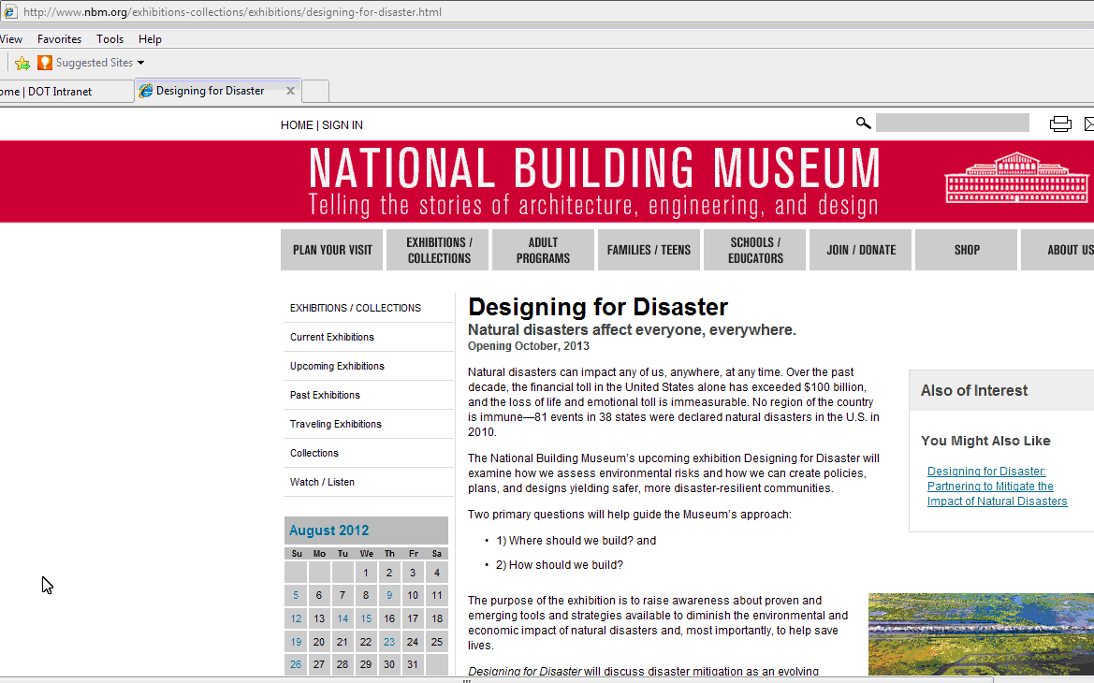

Participants
Name | Organization Representing | Company | Email
Cynthia Munyon* | NAPSR | Iowa Utilities Board | cynthia.munyon@iub.iowa.gov
Steve Fischer | PHMSA | Pipeline and Hazardous Materials Safety Administration (PHMSA) | Steve.fischer@dot.gov
Christie Murray | PHMSA | PHMSA | Christie.murray@dot.gov
Annmarie Robertson | PHMSA | PHMSA | Annmarie.robertson@dot.gov
Julie Halliday* | PHMSA | PHMSA | Julie.Halliday@dot.gov
Andrew Kohout | FERC | Federal Energy Regulatory Commission | andrew.kohout@ferc.gov
Doug Sipes | FERC | Federal Energy Regulatory Commission | doug.sipes@ferc.gov
James Davenport | NACo | National Association of Counties | jdavenport@naco.org
Jim Philipps | NACo | National Association of Counties | jphilipps@naco.org
Chuck Lesniak | NLC | City of Austin, TX | chuck.lesniak@austintexas.gov
Julia Pulidindi | NLC | National League of Cities | pulidindi@nlc.org
Erika Lee | CGA | Common Ground Alliance | erikaa@commongroundalliance.com
Rebecca Craven | PST | Pipeline Safety Trust | rebecca@pstrust.org
Carl Weimer | PST | Pipeline Safety Trust | carl@pstrust.org
Terri Larson | API | Enbridge Energy Company, Inc. | terri.larson@enbridge.com
Aaron Martinez | AOPL | NuStar Energy | Aaron.Martinez@nustarenergy.com
Greg Ford | INGAA | Williams | Greg.r.ford@williams.com
Andrea Grover | INGAA | Spectra Energy | ADGrover@spectraenergy.com
Dwayne Teschendorf | INGAA | Spectra Energy | DETeschendorf@spectraenergy.com
Susan Waller | INGAA | Spectra Energy | SDWaller@spectraenergy.com
Phil Bennett | AGA | American Gas Association | pbennett@aga.org
Chuck Kanoy | AGA | Vectren | bckanoy@vectren.com
Lydia Meigs | AGA | American Gas Association | lmeigs@aga.org
Matthew Wall | VDEM | Virginia Department of Emergency Management | Matthew.Wall@vdem.virginia.gov
Claire Worshtil | NAHB | National Association of Home Builders | cworshtil@nahb.org
Herb Wilhite | Cycla | Cycla Corporation | herbw@cycla.com
* Co-Leaders

